Iteration 5

CIS 320-02

Team: Dancing Ducks

Ashley Aguilera, Aneesa Bell, Eliza Geswein, Skylar Pearcy, Kelechi Ragland, Megan Tharp

Class Diagram

This class diagram was derived using verb-noun analysis. This shows how use cases flow and creates the attributes from nouns, and the methods from verbs. When viewing this class diagram, there are relationships between each class that can be seen. The relationship between these classes will help illustrate how many objects are associated between the classes. Each class is made up of attributes (characteristics) and methods (what the object can do). The two main classes in this diagram are the website user and the administrator. There is one administrator for many of the classes. The administrator can edit different website pages and forms, add wishlist items, accept or deny donations and adoptions, create profiles for the animals, send newsletters, create events, and more. The website user can interact with all of the different forms. The other classes include forms, newsletters, website pages, donations, profiles, and more. There are also some classes that are denoted as “IsPartOf”. These are classes with an aggregation relationship. These classes are part of another class.

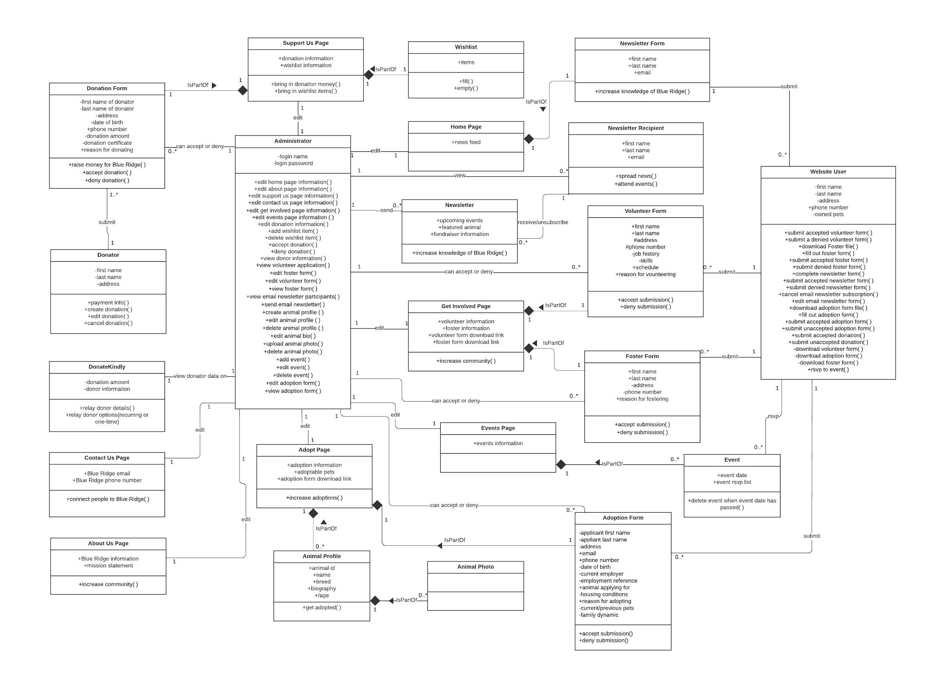

Database Design

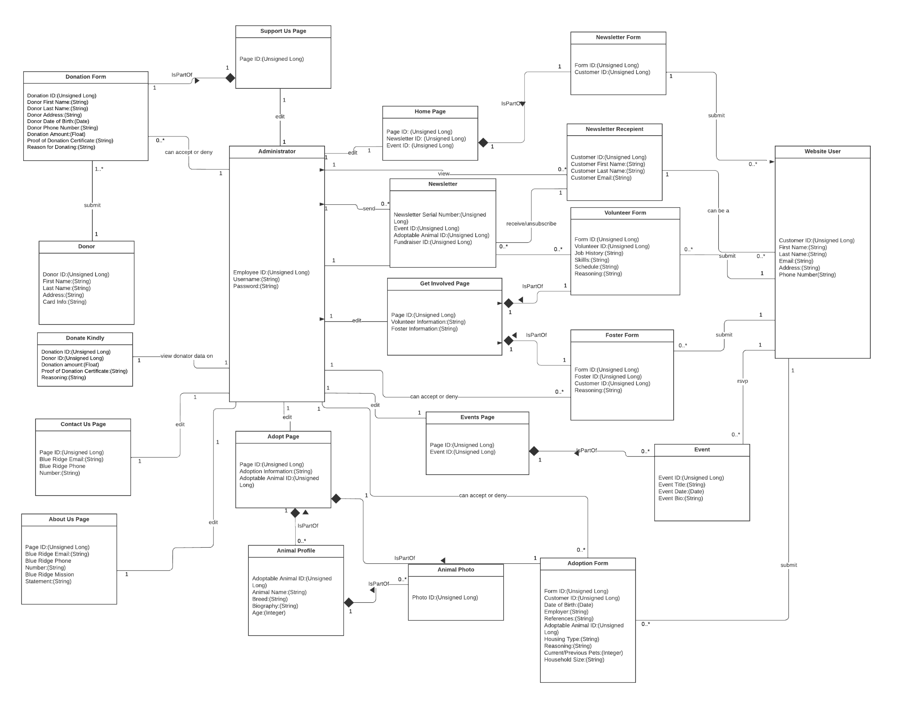

To achieve third normal form, partial dependencies and transitive dependencies were removed. Many tables contained partial dependencies where data about the customer could be determined by only the Customer ID. Those attributes were removed and then added to the Website User table.

Database Definitions

Support Us Page

|  |  |  |  |  |
| --- | --- | --- | --- | --- |
| Attribute | Attribute Definition | Attribute Type | Attribute Size | Key |
| Page ID | Unique identifier for the page | Unsigned long | 4 bytes | Primary |

Donation Form

|  |  |  |  |  |
| --- | --- | --- | --- | --- |
| Attribute | Attribute Definition | Attribute Type | Attribute Size | Key |
| Donation ID | Unique identifier for donations | Unsigned long | 4 bytes | Primary |
| Donor First Name | Donor’s first name | String | 255 bytes max | No |
| Donor Last Name | Donor’s last name | String | 255 bytes max | No |
| Donor Address | Donor’s address | String | 255 bytes max | No |
| Donor Date of Birth | Donor’s date of birth | Date | 3 bytes | No |
| Donor Phone Number | Donor’s phone number | String | 255 bytes max | No |
| Donation Amount | Amount of the donation | Float | 4 bytes | No |
| Proof of Donation Certificate | Verification of transaction | String | 255 bytes max | No |
| Reason for Donating | The donor’s reason for making a donation | String | 255 bytes max | No |

Administrator

|  |  |  |  |  |
| --- | --- | --- | --- | --- |
| Attribute | Attribute Definition | Attribute Type | Attribute Size | Key |
| Employee ID | Unique identifier for the employee | Unsigned long | 4 bytes | Primary |
| Username | Employee’s username | String | 255 bytes max | No |
| Password | Employee’s password | String | 255 bytes max | No |

Home Page

|  |  |  |  |  |
| --- | --- | --- | --- | --- |
| Attribute | Attribute Definition | Attribute Type | Attribute Size | Key |
| Page ID | Unique identifier for the page | Unsigned long | 4 bytes | Primary |
| Newsletter ID | Unique identifier for posts on the page | Unsigned long | 4 bytes | Foreign |
| Event ID | Unique identifier for posts on the page | Unsigned long | 4 bytes | Foreign |

Newsletter Form

|  |  |  |  |  |
| --- | --- | --- | --- | --- |
| Attribute | Attribute Definition | Attribute Type | Attribute Size | Key |
| Form ID | Unique identifier for the form | Unsigned long | 4 bytes | Primary |
| Customer ID | Unique identifier relating to | Unsigned long | 4 bytes | Primary |

Newsletter Recipient

|  |  |  |  |  |
| --- | --- | --- | --- | --- |
| Attribute | Attribute Definition | Attribute Type | Attribute Size | Key |
| Customer ID | Unique identifier for the newsletter recipient | Unsigned long | 4 bytes | Primary |
| Customer First Name | Customer’s first name | String | 255 bytes max | No |
| Customer Last Name | Customer’s last name | String | 255 bytes max | No |
| Customer Email | Customer’s Email | String | 255 bytes max | No |

Website User

|  |  |  |  |  |
| --- | --- | --- | --- | --- |
| Attribute | Attribute Definition | Attribute Type | Attribute Size | Key |
| Customer ID | Unique identifier for the user | Unsigned long | 4 bytes | Primary |
| First Name | Customer’s first name | String | 255 bytes max | No |
| Last Name | Customer’s last name | String | 255 bytes max | No |
| Email | Customer’s email | String | 255 bytes max | No |
| Address | Customer’s address | String | 255 bytes max | No |
| Phone Number | Customer’s phone number | String | 255 bytes max | No |

Volunteer Form

|  |  |  |  |  |
| --- | --- | --- | --- | --- |
| Attribute | Attribute Definition | Attribute Type | Attribute Size | Key |
| Form ID | Unique identifier for the form | Unsigned long | 4 bytes | Primary |
| Volunteer ID | Unique identifier for the volunteer | Unsigned long | 4 bytes | Primary |
| Job History | Volunteer’s | String | 255 bytes max | No |
| Skills | Volunteer’s skills | String | 255 bytes max | No |
| Schedule | Volunteer’s availability | String | 255 bytes max | No |
| Reasoning | Volunteer’s reason for volunteering | String | 255 bytes max | No |

Newsletter

|  |  |  |  |  |
| --- | --- | --- | --- | --- |
| Attribute | Attribute Definition | Attribute Type | Attribute Size | Key |
| Newsletter Serial Number | Unique identifier for the newsletter | Unsigned long | 4 bytes | Primary |
| Event ID | Unique identifier for the events featured | Unsigned long | 4 bytes | Foreign |
| Adoptable Animal ID | Unique identifier for the animals featured | Unsigned long | 4 bytes | Foreign |
| Fundraiser ID | Unique identifier for the fundraisers featured | Unsigned long | 4 bytes | Foreign |

Get Involved Page

|  |  |  |  |  |
| --- | --- | --- | --- | --- |
| Attribute | Attribute Definition | Attribute Type | Attribute Size | Key |
| Page ID | Unique identifier for the page | Unsigned long | 4 bytes | Primary |
| Volunteer Information | Featured volunteer information | String | 255 bytes max | No |
| Foster Information | Featured foster information | String | 255 bytes max | No |

Foster Form

|  |  |  |  |  |
| --- | --- | --- | --- | --- |
| Attribute | Attribute Definition | Attribute Type | Attribute Size | Key |
| Form ID | Unique identifier for the form | Unsigned long | 4 bytes | Primary |
| Foster ID | Unique identifier for the foster animal | Unsigned long | 4 bytes | Primary |
| Customer ID | Unique identifier for the customer | Unsigned long | 4 bytes | Primary |
| Reasoning | Customer’s reason for fostering | String | 255 bytes max | No |

Event

|  |  |  |  |  |
| --- | --- | --- | --- | --- |
| Attribute | Attribute Definition | Attribute Type | Attribute Size | Key |
| Event ID | Unique identifier for the event | Unsigned long | 4 bytes | Primary |
| Event Title | Title of event | String | 255 bytes max | No |
| Event Date | Date of event | Date | 3 bytes | No |
| Event Bio | Description of event | String | 255 bytes max | No |

Events Page

|  |  |  |  |  |
| --- | --- | --- | --- | --- |
| Attribute | Attribute Definition | Attribute Type | Attribute Size | Key |
| Page ID | Unique identifier for the page | Unsigned long | 4 bytes | Primary |
| Event ID | Unique identifier for events featured | Unsigned long | 4 bytes | Foreign |

About Us Page

|  |  |  |  |  |
| --- | --- | --- | --- | --- |
| Attribute | Attribute Definition | Attribute Type | Attribute Size | Key |
| Page ID | Unique identifier for the page | Unsigned long | 4 bytes | Primary |
| Blue Ridge Email | Email for organization | String | 255 bytes max | No |
| Blue Ridge Phone Number | Phone number for organization | String | 255 bytes max | No |
| Blue Ridge Mission Statement | Mission statement for organization | String | 255 bytes max | No |

Adopt Page

|  |  |  |  |  |
| --- | --- | --- | --- | --- |
| Attribute | Attribute Definition | Attribute Type | Attribute Size | Key |
| Page ID | Unique identifier for the page | Unsigned long | 4 bytes | Primary |
| Adoption Information | Information regarding adoption | String | 255 bytes max | No |
| Adoptable Animal ID | Unique identifier for adoptable animals | Unsigned Long | 4 bytes | Foreign |

Animal Profile

|  |  |  |  |  |
| --- | --- | --- | --- | --- |
| Attribute | Attribute Definition | Attribute Type | Attribute Size | Key |
| Adoptable Animal ID | Unique identifier for the animal | Unsigned long | 4 bytes | Primary |
| Animal Name | Animal’s name | String | 255 bytes max | No |
| Breed | Animal’s breed | String | 255 bytes max | No |
| Biography | Animal’s biography | String | 255 bytes max | No |
| Age | Animal’s age | Integer | 4 bytes | No |

Animal Photo

|  |  |  |  |  |
| --- | --- | --- | --- | --- |
| Attribute | Attribute Definition | Attribute Type | Attribute Size | Key |
| Photo ID | Unique identifier for the photo | Unsigned long | 4 bytes | Primary |

Adoption Form

|  |  |  |  |  |
| --- | --- | --- | --- | --- |
| Attribute | Attribute Definition | Attribute Type | Attribute Size | Key |
| Form ID | Unique identifier for the form | Unsigned long | 4 bytes | Primary |
| Customer ID | Unique identifier for the customer | Unsigned long | 4 bytes | Primary |
| Adoptable Animal ID | Unique identifier for the animal | Unsigned long | 4 bytes | Primary |
| Date of Birth | Customer’s date of birth | Date | 3 bytes | No |
| Employer | Customer’s employer | String | 255 bytes max | No |
| References | Customer’s references | String | 255 bytes max | No |
| Housing Type | Customer’s housing type | String | 255 bytes max | No |
| Household Size | Customer’s household size | String | 255 bytes max | No |
| Reasoning | Customer’s reason for adopting | String | 255 bytes max | No |

Donor

|  |  |  |  |  |
| --- | --- | --- | --- | --- |
| Attribute | Attribute Definition | Attribute Type | Attribute Size | Key |
| Donor ID | Unique identifier for the donor | Unsigned long | 4 bytes | Primary |
| First Name | Donor’s first name | String | 255 bytes max | No |
| Last Name | Donor;s last name | String | 255 bytes max | No |
| Address | Donor’s address | String | 255 bytes max | No |
| Card Information | Donor’s card information | String | 255 bytes max | No |

Donate Kindly

|  |  |  |  |  |
| --- | --- | --- | --- | --- |
| Attribute | Attribute Definition | Attribute Type | Attribute Size | Key |
| Donation ID | Unique identifier for the donation | Unsigned long | 4 bytes | Primary |
| Donor ID | Unique identifier for the donor | Unsigned long | 4 bytes | Foreign |
| Donation Amount | Amount of the donation | Float | 4 bytes | No |
| Proof of Donation | Verification of transaction | String | 255 bytes max | No |
| Reasoning | Reason for donation | String | 255 bytes max | No |

Contact Us Page

|  |  |  |  |  |
| --- | --- | --- | --- | --- |
| Attribute | Attribute Definition | Attribute Type | Attribute Size | Key |
| Page ID | Unique identifier for the page | Unsigned long | 4 bytes | Primary |
| Blue Ridge Email | Email for the organization | String | 255 bytes max | No |
| Blue Ridge Phone Number | Phone number for the organization | String | 255 bytes max | No |

User Interface Navigation Diagram and Screen Layouts

The Window Navigation Diagram shows the basic parts of the system. It shows how the user can interact with the system as well as how the windows, buttons, forms, and other objects interact with each other.

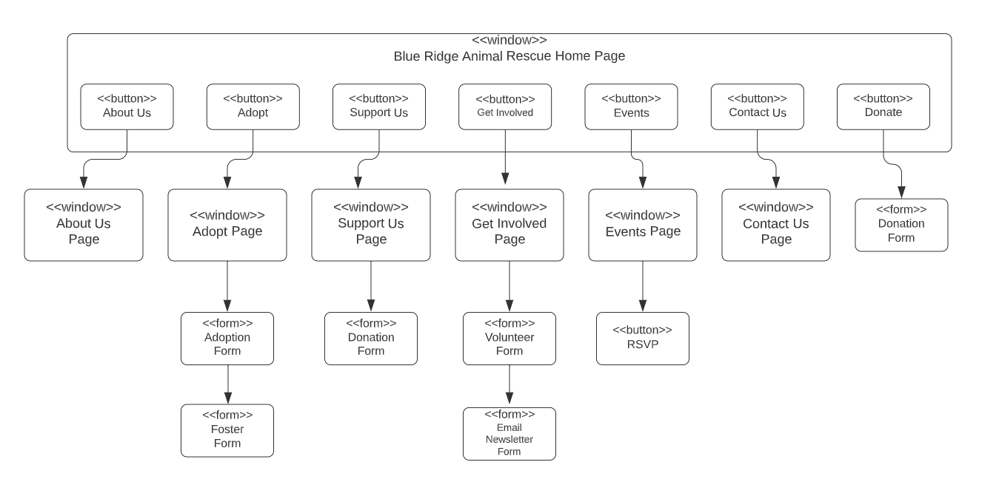

**Creating a schedule refers to the process of setting up a plan or timetable for a particular task, event, or activity. This involves determining the start and end times, duration, frequency, and any other relevant details.**

**Updating a schedule refers to the process of making changes to an existing schedule. This could include modifying the start and end times, changing the frequency or duration of the task, or making adjustments to any other relevant details.**

**Deleting a schedule refers to the process of removing an existing schedule from the system or software. This could be necessary if the task or activity is no longer required, or if there are significant changes to the project plan that require a new schedule to be created.**

**Outlook calendar is a feature in Microsoft Outlook that allows you to create, manage and organize your appointments, meetings and events. With Outlook calendar, you can create new events, schedule meetings, set reminders and receive notifications.**

**An embedded Outlook calendar is a feature that allows you to insert a calendar into other applications, such as a website or a document. This calendar can be edited to add or remove events or to change details of existing events.**

**Similarly, an embedded Outlook calendar can also be deleted. This means that you can remove the calendar from the application or webpage where it was embedded, and it will no longer be visible or accessible.**

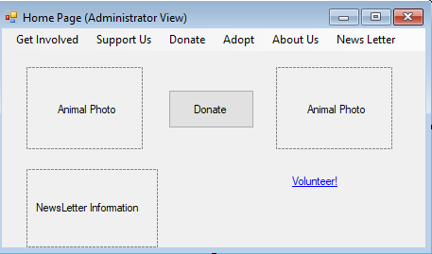

**Create, Edit, and Delete News Feed**

The news feed for the website is an important aspect for Blue Ridge to share information on upcoming events, ways customers can adopt, and to inform customers of the new pets that have arrived for adoption. The news feed needs to keep being updated when it is necessary and the administrator for the website will be in charge of that process. The administrator will be capable of creating the news feed when new information must be shared, and have the ability to edit the news feed after the information has been posted to keep it accurate. The administrator will also have the right to delete the news feed if necessary for misinformation or other issues with the news. The use case prototype shows the way the form input screenlayout will be shown for the news feed for an administrator working for Blue Ridge.

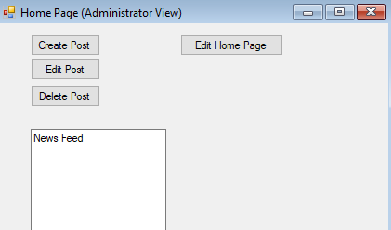

**Edit the About Us Page**

The about us page on any website is an important part of the website to explain to the customers viewing the website the values and the mission that the company upholds. The about us page on the Blue Ridge website upholds the same meaning for their About Us Page and the input screen layout for this page is in the view of the administrator working on the website. Blue Ridge’s About Us information needs to be accessible for changes if the Blue Ridge About Us information is needed to change some more in the future and the administrator is in control of that information for the business. The use case describes that the administrator can edit the page as they please for the website.

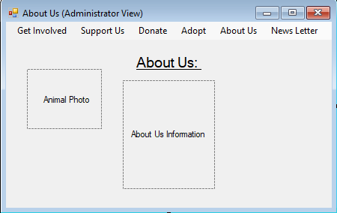

**Edit the Adopt Page Information**

The adopt page information will be accessible to administrators for editing and creating new layouts for the adopt page. This page is important for the business because the animals need to be portrayed well for the potential adopter to learn more about them. This page will also allow access for the user to get to the adoption form from this page so that they could adopt the pet they may desire. The administrator must have the correct credentials so they could access this portion of the website.

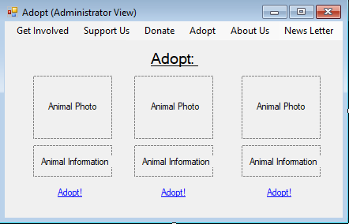

**Create, Edit, Delete Animal Profile**

The animal profiles serve a purpose in the adoption process for the Blue Ridge Website and the content for the page can be created, edited, and deleted for the animal profiles. These profiles need to be cared for so that the animals have a good background for any website user to access and learn more about them before deciding to adopt them. The animal profile page can be edited this way by an administrator with access to the page on the Blue Ridge Website.

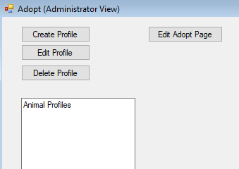

**Download or Fill Out the Adoption Form**

The website user can download or fill out the adoption form on the Blue Ridge website. The user will have access to a link that will download the adoption form to their computer for a more convenient means in case they want to input more precise information in their form. The user on the website can also input the data on the website so they could just submit it easier through the website. This is an important part for the website so that the user can have many different ways to complete the adoption form.

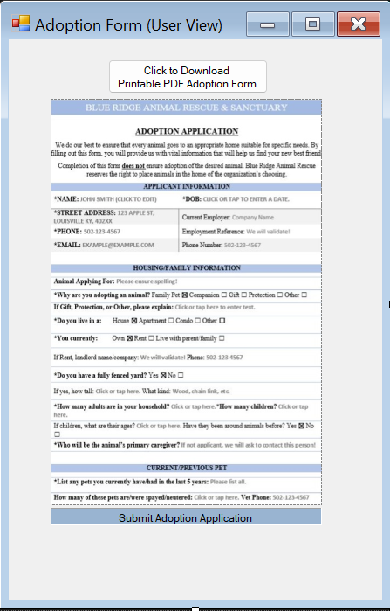

**Edit the Adoption Form**

The administrator for the Blue Ridge Website will be able to access the site and edit the adoption form that the website users will input the data. The administrator needs to be able to have access to the adoption form so that they could keep the website updated. The way the adoption form works needs to be efficient so that the forms sent can be accepted for processing for the adoptions for pets at Blue Ridge.

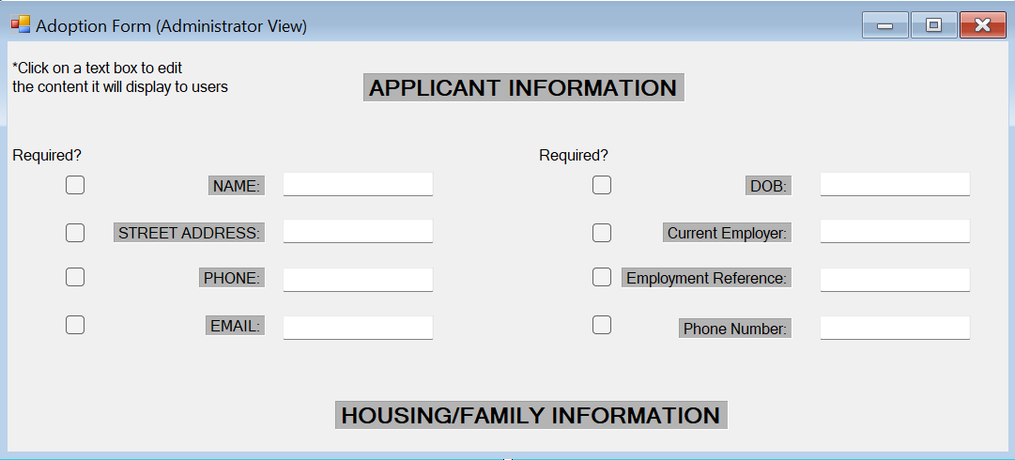

**Edit Support Us Information**

The support us information can be edited by an administrator on the Blue Ridge website. This capability will be good to keep all the information updated so that a user on the site can find the information on how they can be helpful for the company. The administrator will just need accessible credentials to get on the website and change the information. The support us page is important so that more will want to reach out to the company and provide assistance.

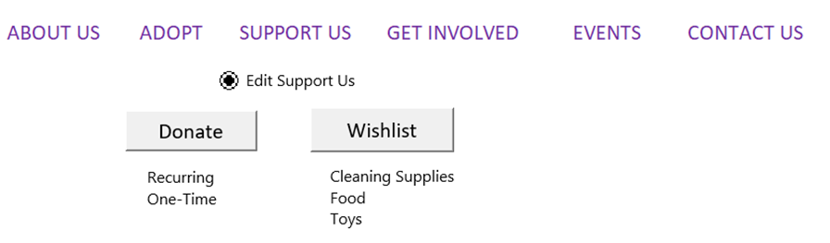

**Create, Edit and Cancel the Donation**

The user will be able to access the donation portion of the website where they can create a donation amount, edit the donation amount, and cancel the donation before submission. It is important for them to be able to have multiple ways to access the donations so that the user can have an easier way to distribute their donation. Donating is an important part for Blue Ridge as it is an aspect that helps to fund the way the company can run their animal services.

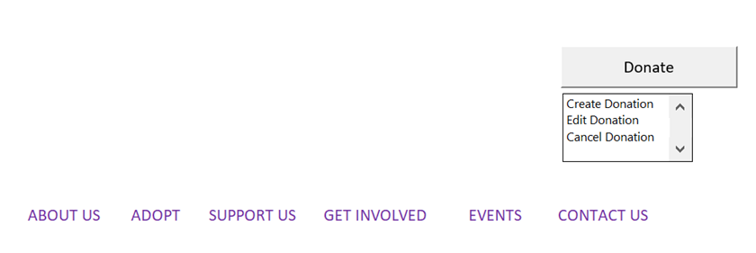

**Edit Events Page Information, and Add, Edit, Delete Events**

The events need to be accessible for viewing for the users that go on the website. These events will happen throughout the year to help support exposure for Blue Ridge and to allow some more donations for the company as well. The administrator will have the access to edit the information on the events page and keep it updated by adding new events, editing the way the edits are described, and deleting events that were canceled or changed. Overall, the events are important to sustain the effectiveness of exposure for the animals and potential adopters.

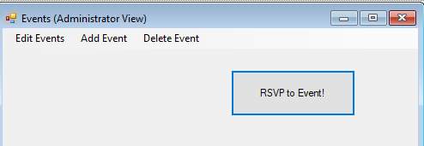

**Edit Get Involved Page Information**

The get involved page is important for the website to show that the users who go on the website can have a way to help the company in its business processes and animal care methods. The get involved page can be edited by an administrator with access. The information on the get involved page must be kept updated just in case some new information on business processes are changed in the future. The input form layout shows what it looks like for the administrator when they enter their edit view for it.

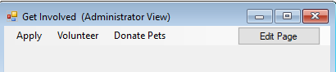

**Download the Volunteer File, Fill out the Volunteer Form, and Edit the Volunteer Form**

The Volunteer Forms are part of the support process for Blue Ridge. These forms are added to the website to give the users a chance to have a way to help with animals at Blue Ridge. The users will have the ability to download the volunteer form from the website and to fill out the form on the website if need be. These are processes to help the users have a way to fill out the volunteer form in whatever they seem fit. An administrator will also have access to edit the volunteer form so that it will appear in the way it needs to be for the user to fill out the information correctly.

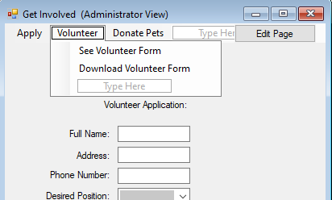

**Download the Foster Form, Fill out the Foster Form, and Edit the Foster Form**

The user will have access to download the foster form on the website's page. This way of reaching the form can be helpful for those who may want to input the information physically by printing it or find it easier to input the information elsewhere. The user will have the ability to fill out the form on the website as well if they want to do it quickly and immediately making it an easier submission through that process of completing the form. An administrator will be able to edit the foster form which will allow it to keep it updated overtime for the user to access. The foster form is another important part for the adoption process.

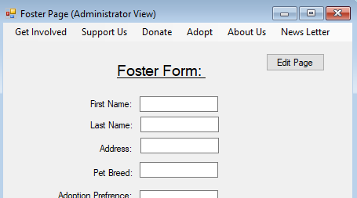

**Complete the Newsletter Form, Edit Email Newsletter Form, and Send Email Newsletter Form**

The newsletter forms are presented on the site to help the website users show the information they want about the pets that have just entered Blue Ridge, and to add information of their own experience with the company’s animals. A website user is allowed to write a newsletter form for the website and subscribe to the newsletter as well. The newsletter form can be edited and sent by the administrators through the website. The editing for the newsletter is important so that they can keep the information accurate and updated overtime so that the customers can have a way to share their own experiences. Sending the newsletter form can be helpful to reach out to the people who are already associated with Blue Ridge and want more information.

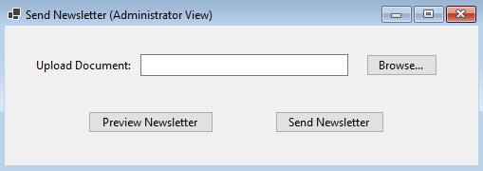

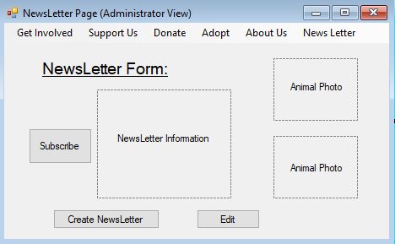

**Data Presentation:**

These layouts are mockups of the system’s data presentation, or how the system responds to user input. This can include accepting or rejecting a form based on if the input meets validation rules, or previewing a form before submission.

**Adoption Form Accept/Deny Submission:**

This shows a mockup of how the system will respond to an adoption form submission. Based on how the system administrator creates the form, there may be required fields or data validation rules that must be met before the adoption form is accepted. If all fields are entered and the inputted data is in the correct format, the form will accept and successfully upload to the database. If any required fields are null, or validation rules are not met, the form will reject and prompt the user with the error preventing submission.

Accept:

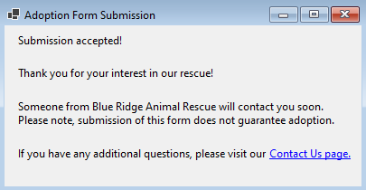

Deny:

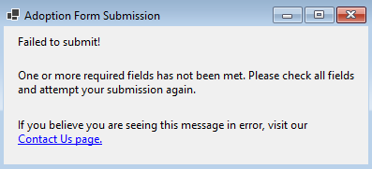

**Donation Form Accept/Deny Submission:**

This shows a mockup of how the system will respond to a donation submission. A donation submission is linked to the payment system, which will likely have many required fields and data validation rules. This can include generic credit card information. If the donation submission recognizes any required fields as null, or data validation rules are not met, the donation will reject and prompt the user to correct the issues. If all required fields are met and data formatting is correct, the donation will be accepted and the user’s card or payment method will be charged.

Accept:

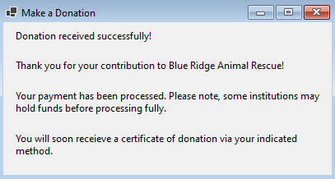

Deny:

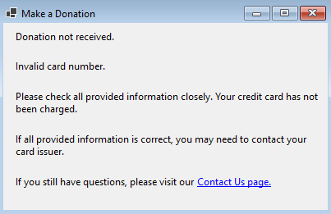

**Volunteer Form Accept/Deny Submission**

This shows a mockup of how the system will respond to a volunteer form submission. Based on how the system administrator creates the form, there may be required fields or data validation rules that must be met before the volunteer form is accepted. If all fields are entered and the inputted data is in the correct format, the form will accept and successfully upload to the database. If any required fields are null, or validation rules are not met, the form will reject and prompt the user with the error preventing submission.

Accept:

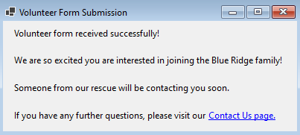

Deny:

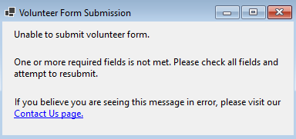

**Foster Form Accept/Deny Submission**

This shows a mockup of how the system will respond to a foster form submission. Based on how the system administrator creates the form, there may be required fields or data validation rules that must be met before the foster form is accepted. If all fields are entered and validation rules are met, the form will accept and upload to the database. If any required fields are null, or validation rules are not met, the form will reject and prompt the user to resubmit.

Accept:

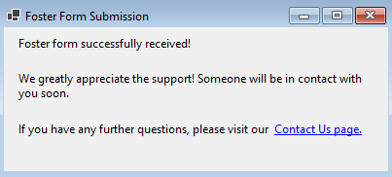

Deny:

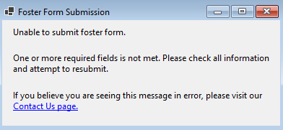

**Newsletter Sign-Up Accept/Deny Submission**

This shows how the system will respond to a newsletter sign-up. If the required fields and data validation rules are met, the sign-up form will submit and add the user to the newsletter. If any required fields are null or data validation rules are not met, the sign-up form will not submit and the user will be prompted to resubmit.

Accept:

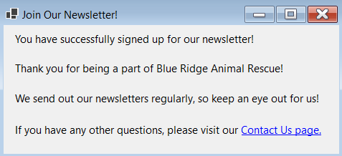

Deny:

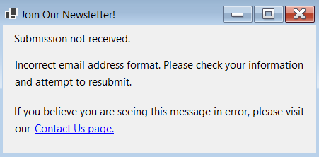

Gantt Chart

A gantt chart is an important tool used in project management to help plan and appropriately schedule tasks among group members to successfully complete a project. Our gantt chart visualizes the tasks for Iteration 2 and the Inception Phase Specification, displaying who has completed each task and the duration each task has taken. It allows for every team member to understand what is expected of them and have knowledge on any dependencies present between tasks, to be able to meet deadlines on time, and to prevent holding back another team member from beginning on their task. It allows for an organized workflow and helps visualize the project.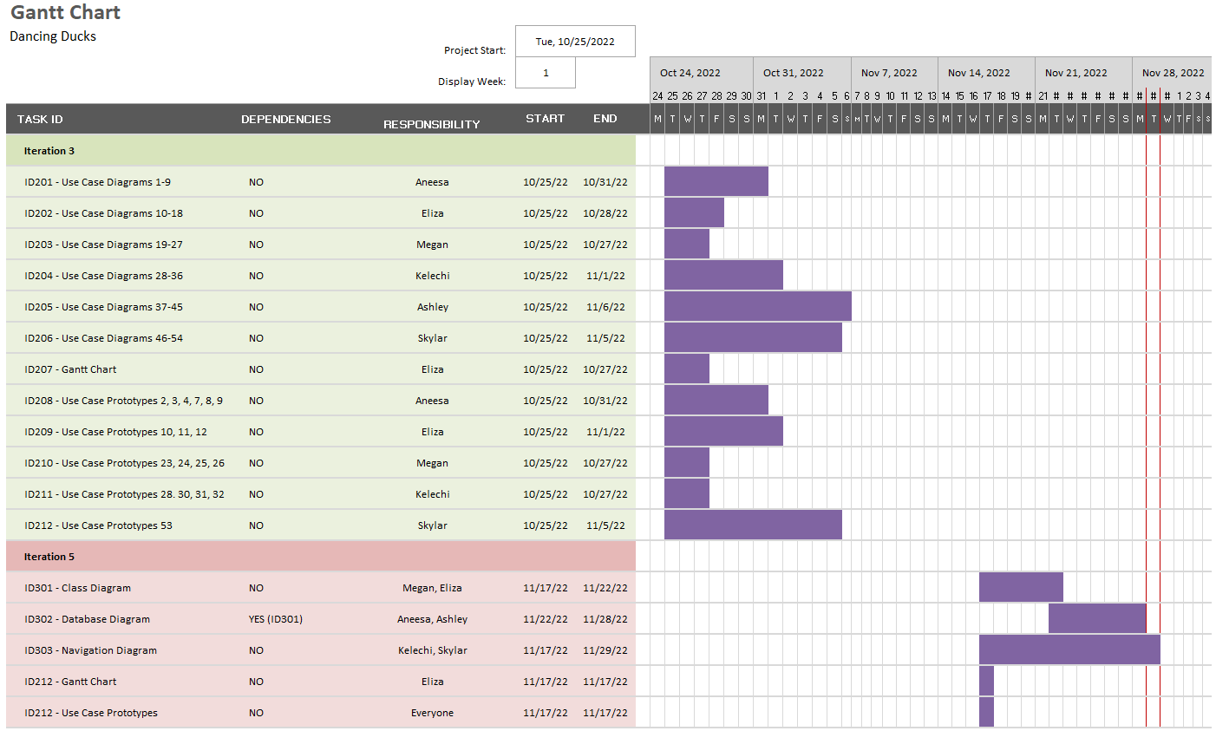

Use Interface Prototypes

**Use Case 1, 2, 3, and 4:** Edit Home Page, Create News Feed Post, Edit News Feed Post, and Delete News Feed Post



**Use Case 5:** Edit About Us Information

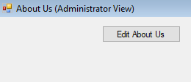

**Use Case 6, 7, 8, and 9:** Edit Adopt Information, Create Animal Profile, Edit Animal Profile, and Delete Animal Profile



**Use Case 10:** Edit Animal Bio

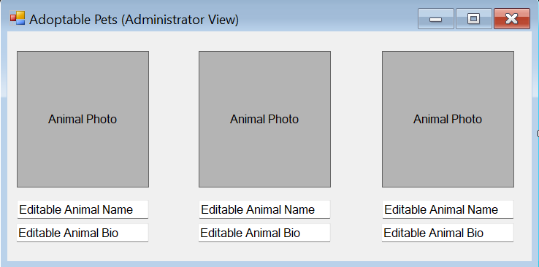

**Use Case 11**: Upload Animal Photo, **Use Case 12**: Delete Animal Photo

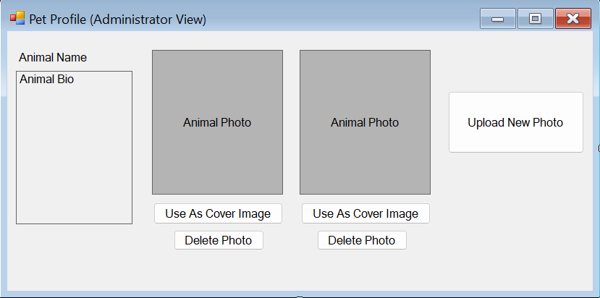

**Use Case 13**: Download Adoption File, **Use Case 14**: Fill Out Adoption Form, **Use Case 15**: Submit Accepted Adoption Form, **Use Case 16**: Submit Denied Adoption Form



**Use Case 17**: Edit Adoption Form



**Use Case 18**: View Adoption Application

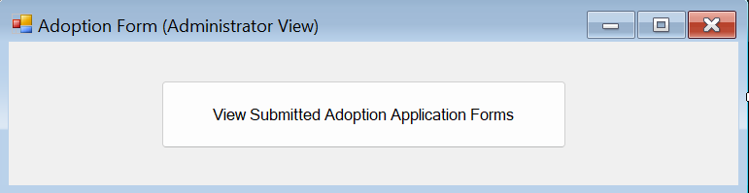

**Use Case 19:** Edit Support Us Information

**Use Case 20, 21, 22:** Create Donation, Edit Donation, Cancel Donation

**Use Case 23 and 24:** Add Wishlist Item and Delete Wishlist Item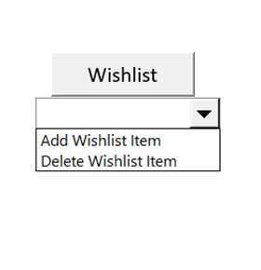

**Use Case 25 and 26:** Accept Donation and Deny Donation 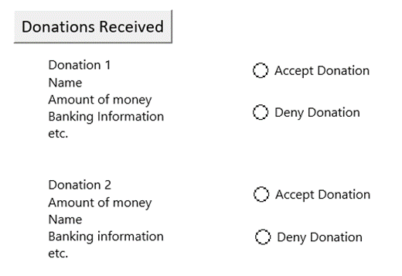

**Use Case 27:** View Donor Information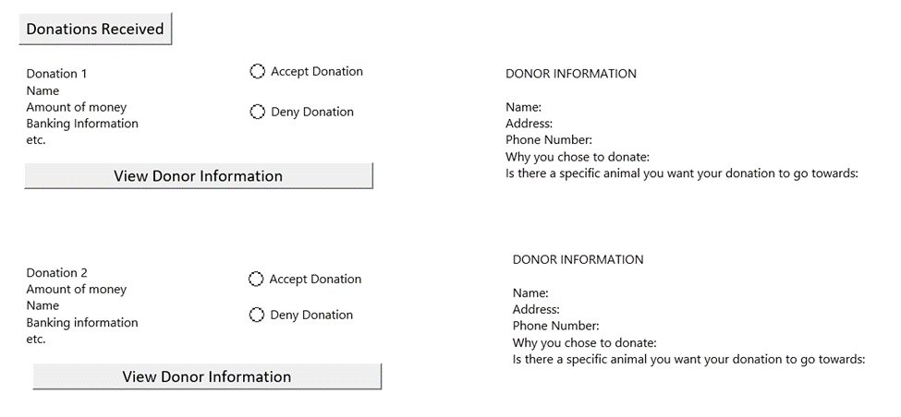

**Use Case 28: Encrypt Donor Information**

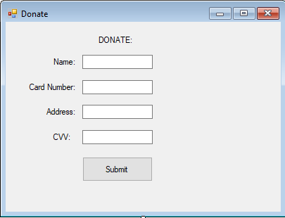

**Use Cases 29, 30, 31, 32 and 33: Edit Events Page Information, Add Event, Edit Event, Delete Event, and RSVP to Event**



**Use Case 34: Edit Get Involved Information**



**Use Case 35 and 36: Download Volunteer File and Fill Out Volunteer Form**

**Use Case 37: Volunteer Form Submission Accept**

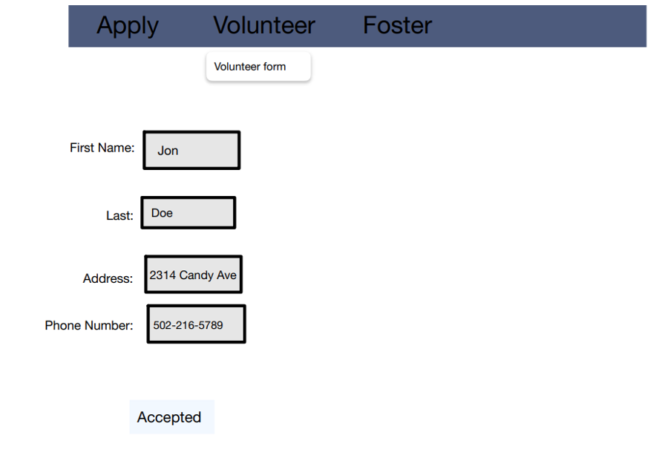

**Use Case 38: Volunteer Form Submission Deny**

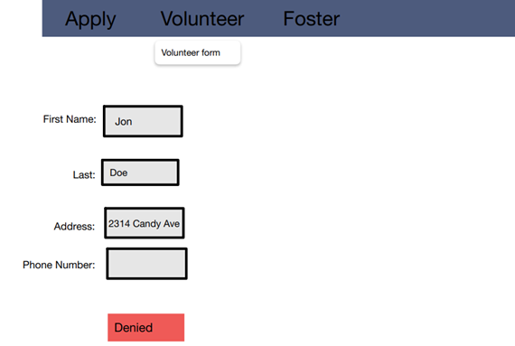

**Use Case 39: Volunteer Form Edit**

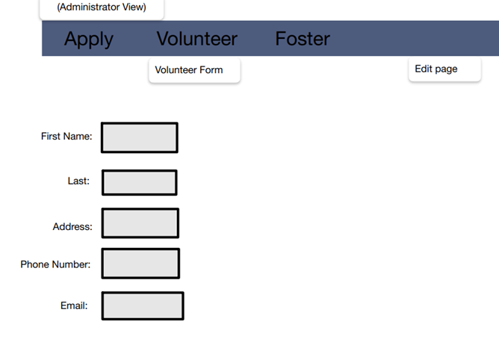

**Use Case 40: View Volunteer Application**

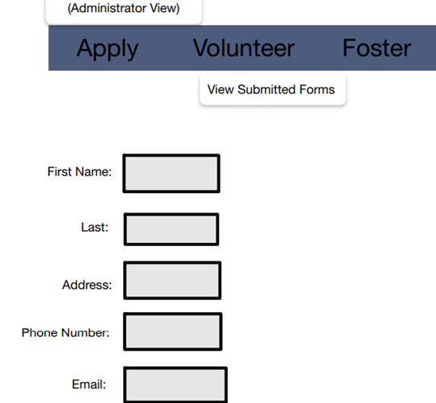

**Use Case 41: Download Foster File**

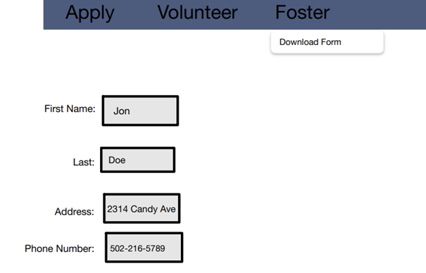

**Use Case 42: Foster Form Input**

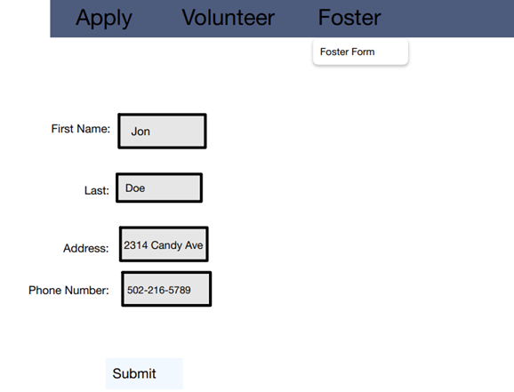

**Use Case 43: Foster Form Submission Accept**

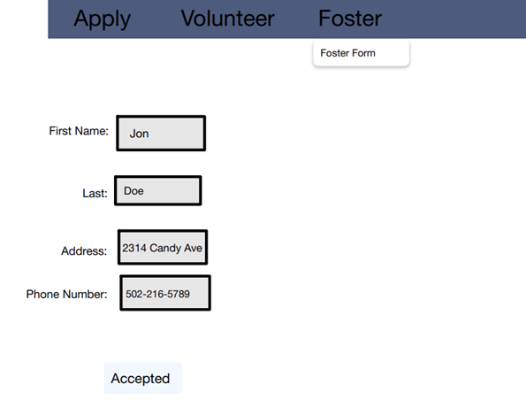

**Use Case 44: Foster Form Submission Deny**

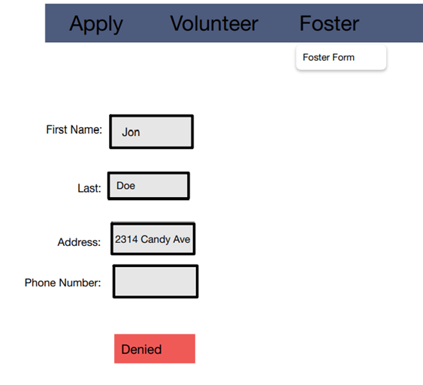

**Use Case 45: Foster Form Edit**

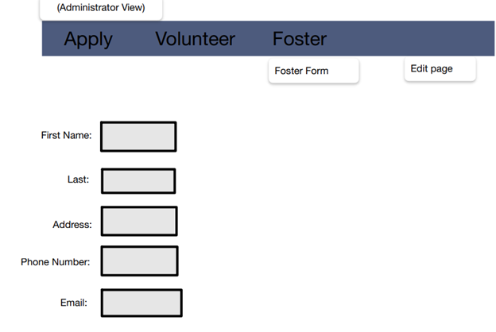

**Use Case 46:** View Foster Application

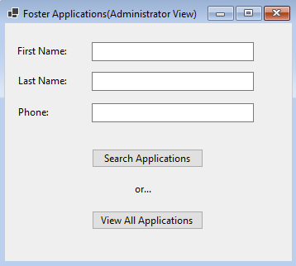

**Use Case 47:** Complete Email Newsletter Form

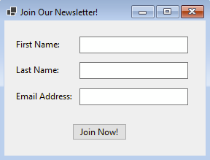

**Use Case 48:** Submit Accepted Email Newsletter Form

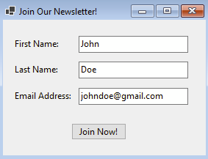

Submission like above will return:



**Use Case 49:** Submit Denied Email Newsletter Form

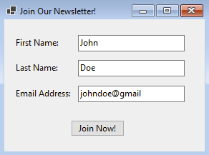

Submission like above will return:



**Use Case 50:** Cancel Email Newsletter Subscription

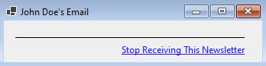

**Use Case 51:** Edit Email Newsletter Form

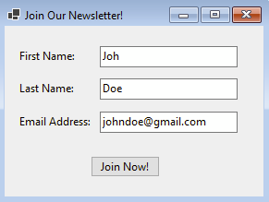

**Use Case 52:** View Email Newsletter Participants

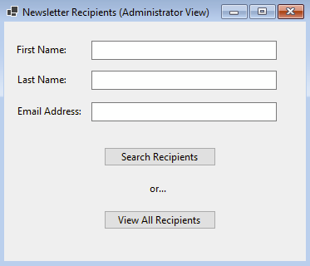

**Use Case 53:** Send Email Newsletter

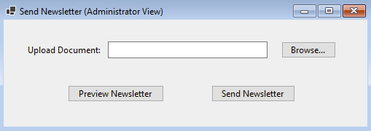

**Use Case 54:** Edit Contact Us Page Information

